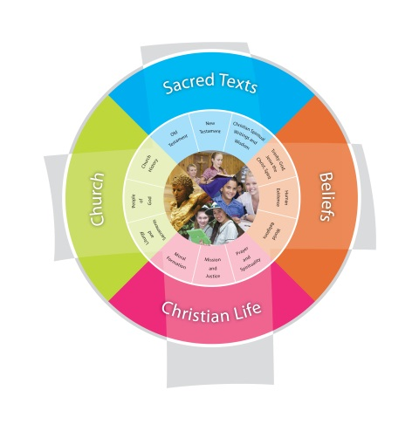
Religion Planning Year Term
Jubilee Primary School Duration:
Fertile Question
VISION for Religious Education
The Vision for Religious Education gives voice to what each school hopes for their students in terms of their religious literacy and faith formation.
The schools and colleges of the Archdiocese of Brisbane aspire to educate and form students who are challenged to live the gospel of Jesus Christ and who are literate in the Catholic and broader Christian tradition so that they might participate critically and authentically in faith contexts and wider society.

Religious Life of the School | General Capabilities | Cross-Curricular Priorities
Religious Identity and Culture  - Ethos and charism (ICE)  - Authentic Christian community (ICC)  - Sense of the Sacred (ICS)  Social Action and Justice  - Justice in the school community (SJS)  - Action for justice (SJA)  - Reflection on action for Justice (SJR)  Evangelisation and Faith Formation  - Living the Gospel (EFG)  - Spiritual Formation (EFF)  - Witness to the wider community (EFW)  Prayer and Worship  - Christian prayer (PWP)  - Celebration of liturgy and sacraments (PWL)  - Ritualising everyday life (PWR) | - Literacy  - Numeracy  - Information and communication technology (ICT) capability  - Critical and creative thinking  - Personal and social capability  - Ethical understanding  - Intercultural understanding. | - Aboriginal and Torres Strait Islander histories, cultures and spiritualities  - Asia and Australia’s engagement with Asia in a multi-faith context  - Sustainability and ecological stewardship.
Year Level Description
The Religion Curriculum involves four strands: Sacred Texts, Beliefs, Church and Christian Life. These strands are interrelated and should be taught in an integrated way; and in ways that are appropriate to specific local contexts.

Achievement Standard
By the end of Year

Class Context for Learning – Differentiated learning
Class Needs
Individualised Learning Needs
Catholics/non-Catholics – other faiths – practising/non-practising
ASD – ADHD (abstract concepts may need further unpacking – visuals etc…)

Learning Intentions
Learning Intention
By the end these learning experiences, students

Success Criteria
Success Criteria

Assessment
Assessment Background

Content Descriptions
Sacred Texts  Old Testament  New Testament  Christian Spiritual Writings and Wisdom  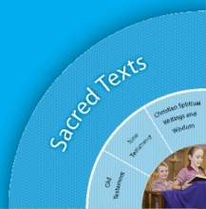 |  | Beliefs  Trinity  Human Existence  World Religions  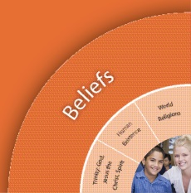
Religious Knowledge and Deep Understanding | Skills | Religious Knowledge and Deep Understanding | Skills
Church  Liturgy and Sacraments  People of God  Church History  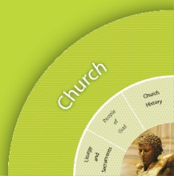 |  | Christian Living  Moral Formation  Mission and Justice  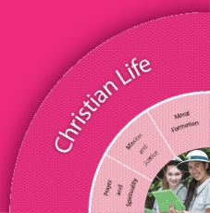  Prayer and Spirituality
Religious Knowledge and Deep Understanding | Skills | Religious Knowledge and Deep Understanding | Skills

Scriptural Texts
Core texts are prescribed Scriptural texts that need to be taught in depth at each year level.
Supplementary texts are other possible Scripture texts that could be used to support the teaching of particular concepts.

Significant Days and Celebrations

Learning Experiences
Core Content Area One  Focus/Question– |  | Resources  Teacher Background  Mandated Scriptural Texts
Tuning In
- What is the topic?
- Why should we study this topic?
- Frame manageable questions.
- What do I already know about this topic? I think I know x,y,z.
- How is this relevant to me?
Finding Out
- Identify possible sources of information
- Identify skills necessary for the investigation.
- How did it happen? Who was there and what were the facts?

Sorting Out
- What do we want to find out?
- How can we do this best?
- How will we gather the information?
- Does what I knew before still apply?
- Does my first idea still make sense?

Communicating
- Extend and challenge students’ understandings
- Offer more information
- Is there something else I need to deepen my knowledge understandings?
- What difference does this make to me?

Reflecting and Evaluating
- So what have I learnt?
- If I know this, how can I connect it with my world?

Core Content Area Two  Focus/Question– |  | Resources  Teacher Background
Tuning In
Finding Out
Sorting Out
Communicating

Reflecting and Evaluating

Core Content Area Three  Focus/Question– |  | Resources  Teacher Background
Tuning In

Finding Out

Sorting Out

Communicating

Reflecting and Evaluating

Brainstorm Ideas for Learning Experiences

2 STARS
Provide some positive feedback on your Religion Unit below. What activities and lessons were engaging for students? What resources were most useful? Were the lesson plan ideas helpful?

1 WISH
What would you change should you teach this unit again? What resources do you wish you could have used to engage children in this unit more?

