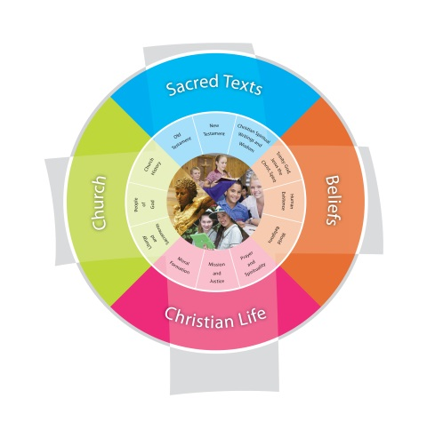
Religion Planning Year 2 “A Covenant People”
Jubilee Primary School Duration: 8 weeks
Fertile Question
What does it mean to be people of God’s covenant?
VISION for Religious Education
The Vision for Religious Education gives voice to what each school hopes for their students in terms of their religious literacy and faith formation.
The schools and colleges of the Archdiocese of Brisbane aspire to educate and form students who are challenged to live the gospel of Jesus Christ and who are literate in the Catholic and broader Christian tradition so that they might participate critically and authentically in faith contexts and wider society.

Religious Life of the School | General Capabilities | Cross-Curricular Priorities
Religious Identity and Culture  - Ethos and charism (ICE)  - Authentic Christian community (ICC)  - Sense of the Sacred (ICS)  Social Action and Justice  - Justice in the school community (SJS)  - Action for justice (SJA)  - Reflection on action for Justice (SJR)  Evangelisation and Faith Formation  - Living the Gospel (EFG)  - Spiritual Formation (EFF)  - Witness to the wider community (EFW)  Prayer and Worship  - Christian prayer (PWP)  - Celebration of liturgy and sacraments (PWL)  - Ritualising everyday life (PWR) | - Literacy  - Numeracy  - Information and communication technology (ICT) capability  - Critical and creative thinking  - Personal and social capability  - Ethical understanding  - Intercultural understanding. | - Aboriginal and Torres Strait Islander histories, cultures and spiritualities  - Asia and Australia’s engagement with Asia in a multi-faith context  - Sustainability and ecological stewardship.
Year Level Description
The Religion Curriculum involves four strands: Sacred Texts, Beliefs, Church and Christian Life. These strands are interrelated and should be taught in an integrated way; and in ways that are appropriate to specific local contexts. In Year 2, students learn about aspects of God’s nature and God’s relationship with people, as they engage with a variety of New Testament texts depicting the teachings and actions of Jesus, and Old Testament texts that describe God’s relationship with the Jewish people. They explore contextual information about the first century Mediterranean world, to better appreciate the life and times of Jesus. They learn about Jesus’ mission and ministry and explore ways in which Jesus’ teachings and actions continue to guide the life of the Church community today. They explore, recognise and appreciate the history of a parish community as it is revealed in many ways.
learn about the sacredness of all creation, especially human life; the call to be co-creators and stewards of God’s creation; and the responsibility to pursue peace and justice out of respect for human life and all creation. They develop their understanding of the loving relationship God offers to people unconditionally; and their understanding of sin, as evident in the free choices that harm the individual and their loving relationships with God, with others and with all creation. They explore ways in which believers seek to heal these relationships through reconciliation and prayer. They investigate ways in which believers celebrate reconciliation with God and with others in the Sacrament of Penance. They examine ways in which prayer and the wisdom of the saints help believers to nurture their loving relationships with God, with others and with all creation. They develop their understanding of prayer in the Christian tradition through an exploration of prayer for forgiveness (acts of contrition and Penitential Act) and meditative prayer.

Achievement Standard
By the end of Year 2, students analyse some teachings and actions of Jesus depicted in New Testament texts that reveal aspects of God’s nature. They discuss their ideas about God’s relationship with the Jewish people as described in some Old Testament stories. They pose questions about the life and times of Jesus and use sources provided to answer these questions. They make connections between Jesus’ teachings and actions and the way members of the Church community live today. They recognise the sacredness of God and all creation, especially human life. They identify ways in which human beings respond to the call to be co-creators and stewards of God’s creation. They suggest ways to pursue peace and justice out of respect for human life and all creation, drawing on their own experiences. They recognise free choices that harm an individual and their loving relationships with God, with others and with all creation. They explain ways in which believers seek to heal these relationships through reconciliation and how they celebrate reconciliation in the Sacrament of Penance. They recognise that prayer and the wisdom of the saints help the believer to nurture their relationship with God, with others and with all creation. They participate with respect in a variety of personal and communal prayer experiences, including meditative prayer and prayers for forgiveness.

Class Context for Learning
Class Needs
Multi-faith traditions – Catholic, Anglican, Uniting, Apostolic
Practising / Non-practising members

Learning Intentions
- Describe Jewish understanding of covenant as agreement between God and the Jewish people
- Record examples of how the covenant is lived in the daily lives of Jewish people today
- Identify behaviours and actions in some Old Testament stories that reveal aspects of God’s nature (loving, just, relational, forgiving)
- Share and compare ideas and opinions with others about God’s relationship with people in Old Testament stories

Success Criteria
- Discuss ideas about God’s relationship with the Jewish people as described in some Old Testament stories

Assessment
Focus Area 1: Children sequence the events in order for one of the Old Testament Stories. Extension questions for those achieving above after sequencing are based around their understanding of Covenant and what it means to have a Covenant with God.
Focus Area 2: Design a personal prayer mat. Include in your design: an image of God, an explanation of what prayer means to you, sketches of symbols of prayer, an example of a personal prayer, and an ‘agreement’ you can make with God about growing your friendship with God.

Content Descriptions
Sacred Texts  Old Testament  New Testament  Christian Spiritual Writings and Wisdom  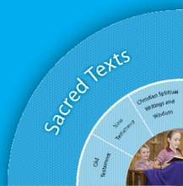 |  | Beliefs  Trinity  Human Existence  World Religions  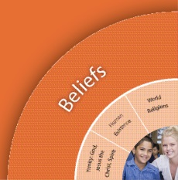
Religious Knowledge and Deep Understanding | Skills | Religious Knowledge and Deep Understanding | Skills
STOT5 - The Church teaches that the Bible is an inspired account of God’s self-revelation. The Old Testament describes God’s relationship with the Jewish people. The Abraham and Sarah story is one example of how God relates with people (e.g. the call of Abraham and Sarah, Genesis 17: 1-8; 15-22). | Identify people, places, events and things in some Old Testament stories  Identify behaviours and actions in some Old Testament stories that reveal aspects of God’s nature (e.g. loving, just, relational, forgiving)  Share and compare ideas and opinions with others about God’s relationship with people in Old Testament stories. | BEWR3 - The Jewish people are a covenant people. Their relationship with God is expressed in their daily lives. | Describe the Jewish understanding of covenant as agreement between God and the Jewish people.  Record and report examples of how the covenant is lived in the daily lives of Jewish people today.
Church  Liturgy and Sacraments  People of God  Church History  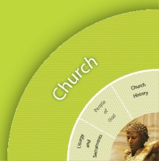 |  | Christian Living  Moral Formation  Mission and Justice  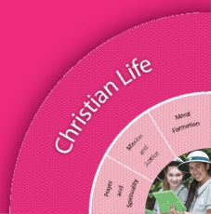  Prayer and Spirituality
Religious Knowledge and Deep Understanding | Skills | Religious Knowledge and Deep Understanding | Skills
 |  | CLPS5 - Prayer involves talking and listening to God, either alone or gathered as community. Believers pray with the help of word, music, action, silence, images, symbols and nature.  Prayer in the Christian tradition, including prayer for forgiveness, nurtures the spiritual life of believers. | Participate with respect in a variety of personal and communal prayer experiences, including prayer for forgiveness, that nurture the spiritual life of believers.
 |  | CLPS2 - Meditative prayer uses silence and stillness to assist believers to listen and talk to God.  There is a range of practices for preparing the body and the mind for meditative prayer (e.g. relaxing the body, centred breathing, attending to posture, being silent and still, recitation of mantras, closing eyes).  A range of spiritual exercises drawn from the Christian tradition helps believers engage in the ‘work of meditation’ (e.g. praying with the help of: beads, labyrinths, images, music, mandalas, mantras, journaling, colour, chimes / bells / rain sticks, candles, symbols, sacred spaces, patterns, rhythms and movement). | Participate respectfully in meditative prayer.  Identify and use practices and spiritual exercises that assist them to prepare for and engage in meditative prayer.

Scriptural Texts
Mandated Scripture  God's agreement with Noah  Genesis 9:8-17  Promise to Abraham and Sarah  Genesis 17:1-8; 15-19; 21-22 | Supplementary Texts  Creation  Psalm 24:1-2  Psalm 50:10-12  Moses - The Two tablets of the Covenant  Exodus 31:18

Significant Days and Celebrations

Learning Experiences
Core Content Area One  Focus/Question God’s Covenant with the Jewish People |  | Resources  Teacher Background  Mandated Scriptural Texts
Tuning In | - Discuss the word Covenant and what it meant for the Jewish people to have a Covenant with God.  - Watch the story of Noah. http://www.youtube.com/watch?v=tPAdWFIgPCo  - Use big chart 5 Ws + H strategy to gather and record key information about people, places, things and events in the Noah story.  - Pose questions and discuss the Covenant between God and Noah. | The Story of Noah
Finding Out | - Watch the story of Joseph and the Coloured Coat. http://www.youtube.com/watch?v=FOoieyA47i0  - Use big chart 5 Ws + H strategy to gather and record key information about people, places, things and events in the Joseph story.  - Pose questions and discuss the Covenant between God and Joseph.  - Watch the story of Abraham and Sarah.  http://www.youtube.com/watch?v=SmEhQyn2Xrc  - Create a visual display of words and images of God from the story.  - Use big chart 5 Ws + H strategy to gather and record key information about people, places, things and events in the Abraham and Sarah story.  - Discuss the Covenant between God and Abraham and Sarah.  - Create a Venn Diagram exploring similarities and differences between two of the Old Testament stories studied.  - Invite a Jewish person to speak to students about the Jewish understanding of covenant and the importance of their ‘agreement’ with God.  - Introduce Judaism: Watch ‘Facts About Judaism’ (3min) and ‘The Story of Judaism’ (5min). Discuss & pose questions about how Jewish people express their relationship with God in their daily lives. (eg prayer & worship, Sabbath observance)  Facts about Judaism:  http://www.youtube.com/watch?v=KzCoWo2eYGA  The story of Judaism:  http://www.youtube.com/watch?v=HyEaAcPGAhA  Jewish Traditions  - Explore images of the daily life of Jewish people today to make connections with the living Covenant.  - Use Big Book to explore Religious artifacts (eg Tefillin, Tallet) and ways in which these are used to help Jewish people remember and live the Covenant in their daily lives.  - How to put on a Tefillin:  http://www.youtube.com/watch?v=cKdr50iLqf8  - How to put on a Tllit:  http://www.youtube.com/watch?v=CNMJKXa9gQA  - Students make a Tefillin and Tilit and explore how they work and practice putting them on. | Joseph and His Coloured Coat  Abraham and Sarah  World Religions and Judaism Big Book
Sorting Out

Communicating | Focus Assessment 1: Students sequence the events in order for one of the Old Testament Stories. Extension questions for those achieving above after sequencing are based around their understanding of Covenant and what it means to have a Covenant with God.
Reflecting and Evaluating | - What is a Covenant with God? How were Noah, Abraham and Sarah, and Joseph with his coloured coat living their Covenant (agreement) with God?  - Recall interesting things that Jewish people do to live their Covenant with God. What signs or symbols do they use?  - Reflect on what we do as Christians that is similar or different to Jewish people about an agreement with God.

Core Content Area Two  Focus/Question How can I live a personal covenant with God? |  | Resources  Teacher Background
Tuning In | - Revisit what ‘covenant’ means. In order to have an agreement, people need to converse, to build up a relationship together. How do we build a friendship with others? What do we do together? What do we do for each other? How do we treat one another? What do we hope for one another? What ‘agreement’ might we make with each other?  - Discuss: How can we build a friendship with God? What can we do together? What can we do for each other? How can we treat each other? What can we hope for one another? How can we communicate with each other? What ‘agreement’ might we be able to make together?
Finding Out | - Discuss: What is prayer? Learn about different ways to pray  - Explore some different ways of calling believers to prayer (e.g. sign of the cross, prayer bells, rain sticks, singing, mantras, music, proclaimers….)  - Learn about the different practices for preparing the body and mind for Meditative Prayer (e.g. relaxing the body, centred breathing, being silent and still, closing eyes)  - Learn about how some spiritual exercises (e.g. lighting a candle, sounding chimes, colouring a mandala) that help believers to listen and talk to God  - Select practices and spiritual exercises that help the students best to calm the body and mind  - Create and use a string of beads for times of silence  - Explore simple ways that believers use spiritual exercises drawn from the Christian tradition (e.g. praying with mantras as in Christian Meditation)  - Focus on scheduled times during the day to gradually lengthen times of stillness and silence for prayer moments  - Use breathing techniques and music to calm the body and bring about stillness  - Engage with guided meditations as a calming tool after play breaks  - Use stimulus materials (e.g. beads, prayer mats, colouring, music, images, labyrinths, battery-operated tea lights) to become more familiar with a range of practices and spiritual exercises  - Use a variety of traditional prayers and devotions for individual and communal use (e.g. simple prayer responses, Lord’s Prayer, Amen, Sign of the Cross, school prayer, blessing before food eating, spontaneous prayer)  - Utilize a diverse range of prayer experiences throughout the Unit (e.g. meditative prayer, communal prayer, traditional prayer, silence, spontaneous prayer) and cultural expressions of prayer
Sorting Out
Communicating | Focus Assessment 2 : Design a personal prayer mat. Include in your design: an image of God, an explanation of what prayer means to you, sketches of symbols of prayer, an example of a personal prayer, and an ‘agreement’ you can make with God about growing your friendship with God.
Reflecting and Evaluating | - Discuss: What have I learnt about prayer? How can I improve my friendship with God? How can I make time with God? What can I talk to God about? What ‘agreement’ with God will help me to grow more as a Christian? How might I be able to keep this agreement alive?

