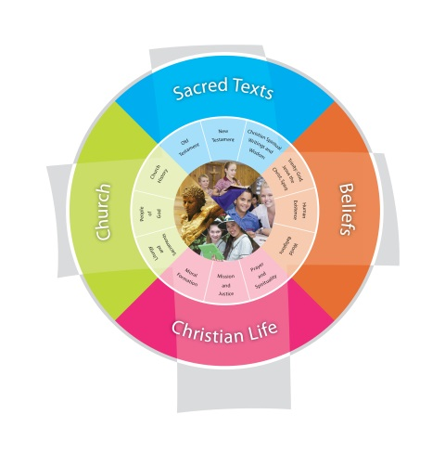
Religion Planning Year 1 “God Speaks to Everyone”
Jubilee Primary School Duration: 7 weeks
Fertile Question
How do we all spread the Good News?
VISION for Religious Education
The Vision for Religious Education gives voice to what each school hopes for their students in terms of their religious literacy and faith formation.
The schools and colleges of the Archdiocese of Brisbane aspire to educate and form students who are challenged to live the gospel of Jesus Christ and who are literate in the Catholic and broader Christian tradition so that they might participate critically and authentically in faith contexts and wider society.

Religious Life of the School | General Capabilities | Cross-Curricular Priorities
Religious Identity and Culture  - Ethos and charism (ICE)  - Authentic Christian community (ICC)  - Sense of the Sacred (ICS)  Social Action and Justice  - Justice in the school community (SJS)  - Action for justice (SJA)  - Reflection on action for Justice (SJR)  Evangelisation and Faith Formation  - Living the Gospel (EFG)  - Spiritual Formation (EFF)  - Witness to the wider community (EFW)  Prayer and Worship  - Christian prayer (PWP)  - Celebration of liturgy and sacraments (PWL)  - Ritualising everyday life (PWR) | - Literacy  - Numeracy  - Information and communication technology (ICT) capability  - Critical and creative thinking  - Personal and social capability  - Ethical understanding  - Intercultural understanding. | - Aboriginal and Torres Strait Islander histories, cultures and spiritualities  - Asia and Australia’s engagement with Asia in a multi-faith context  - Sustainability and ecological stewardship.
Year Level Description
The Religion Curriculum involves four strands: Sacred Texts, Beliefs, Church and Christian Life. These strands are interrelated and should be taught in an integrated way; and in ways that are appropriate to specific local contexts. In Year 1, students explore the Christian teaching that all people are created in God’s own image, with dignity and natural rights. They learn about living in accordance with God’s plan for all creation: living safely and happily in community and in loving relationship with God, with a responsibility to care for all creation, and using God’s gift of freedom to make choices responsibly. They engage with a variety of Old Testament texts to learn about God’s presence in the lives of individuals and communities, and make connections to their own experiences. They explore the words, actions and symbols used in the Sacraments of Baptism and Eucharist to communicate God’s presence and action. They learn about the different roles in the local parish community. They learn about the nature of Jesus’ mission and ministry. They explore aspects of Jewish daily life at the time of Jesus. They listen to, view and read accounts from different Gospels of key events, places and characters in the life of Jesus and explore similarities and differences in these accounts. They explore the many ways in which Mary, Mother of Jesus, is honoured by Christians past and present and develop their understanding of the Hail Mary, a Catholic prayer honouring Mary. They understand that prayer was an important part of Jesus’ life and is important in the lives of believers. They continue to learn about ways in which believers pray, either alone or with others, including morning prayers and Grace.
Achievement Standard
By the end of Year 1, students make connections to personal experience when explaining ways of living in accordance with God’s plan for creation. They learn that people live safely and happily in community and in loving relationship with God, with a responsibility to respect the dignity and natural rights of all people, to care for all creation and to responsibly use God’s gift of the freedom to choose. They relate stories from some Old Testament texts that describe God’s presence in the lives of individuals and communities. They identify words, actions and symbols used in the Sacraments of Baptism and Eucharist to communicate God’s presence and action. They identify the nature of Jesus’ mission and ministry, as well as similarities and differences between Gospel accounts of significant events, places and characters in the life of Jesus. They describe some aspects of Jewish daily life at the time of Jesus. They recognise the many ways in which believers, past and present, honour Mary, Mother of Jesus, including praying the Hail Mary. They recognise the significance of prayer in Jesus’ life and in the life of believers and participate with respect in a variety of personal and communal prayer experiences, including meditative prayer and the Hail Mary.

Class Context for Learning
Class needs
Multi-faith Traditions – Catholic, Anglican, Uniting, Apostolic
Practising / Non-practising members

Learning Intentions
By the end these learning experiences, students
- Compare different roles that people have in local church communities
- Identify key events, places and characters in the life of Jesus as revealed in Gospel passages
- Identify similarities and differences between different Gospel accounts of key events, characters and teachings in the life of Jesus

Success Criteria
- Describe God’s presence in the lives of individuals and church communities
- Identify similarities and differences between Gospel accounts of significant events, places and characters in the life of Jesus

Assessment
Focus Area 1: Students describe how people in the local church community assist God in his work. They explain what people in the photographs are doing for members of their local community.
Focus Area 2: Students listen to two recounts of the miracle story “Jesus Heals a Man”. Using a Scripture Think Pad or Scripture Probe, they identify and write similarities and differences between the accounts of Matthew 8:1-4 and Luke 5:12-16.

Content Descriptions
Sacred Texts  Old Testament  New Testament  Christian Spiritual Writings and Wisdom  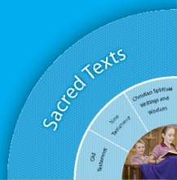 |  | Beliefs  Trinity  Human Existence  World Religions  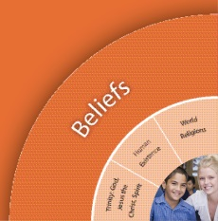
Religious Knowledge and Deep Understanding | Skills | Religious Knowledge and Deep Understanding | Skills
STNT3 - The Gospels of Matthew, Mark, Luke and John provide particular insights into the life and teaching of Jesus. | Identify key events, places and characters in the life of Jesus as revealed in Gospel passages  Identify similarities and differences between different Gospel accounts of key events, characters and teachings in the life of Jesus (e.g. birth, death, Jesus’ family, Jesus’ followers, meal stories, miracles).
Church  Liturgy and Sacraments  People of God  Church History  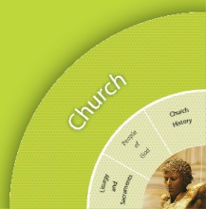 |  | Christian Living  Moral Formation  Mission and Justice  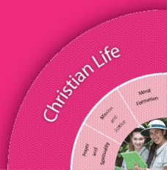  Prayer and Spirituality
Religious Knowledge and Deep Understanding | Skills | Religious Knowledge and Deep Understanding | Skills
CHPG2 - Within a local church community there are many different roles (e.g. priest/minister, parishioner, liturgical ministries such as musicians and altar servers; church groups such as family groups and prayer groups; ministries such as St Vincent de Paul, Anglicare and youth worker). | Compare the different roles that people have in the local church community.

Scriptural Texts
Mandated Scripture  The baptism of Jesus  Mark 1:9-11  esus calls Peter, Andrew, James and John  Matthew 4:18-22  Calling the Twelve  Mark 3:13-19  Lost in the Temple  Luke 2:41-47  Passover  Matthew 26:17-19 | Supplementary Texts  The baptism of Jesus  Matthew 3:13-17  Luke 3:21-22  Jesus ministers and heals  Matthew 4:23-25  Matthew 8:14-17  Matthew 9:2-8  Matthew 14:13-21  Luke 5:17-26  Luke 4:38-41  Wedding at Cana  John 2:1-12  Presentation in the Temple  Luke 2:22-24  Festival of the Booths  John 7:2-8

Significant Days and Celebrations

Learning Experiences
Core Content Area One  Focus/Question– God calls Christians in our Local Church Communities |  | Resources  Teacher Background  Mandated Scriptural Texts
Tuning In | - What do we know about our local church?  - Who are the members of our local church?  - Where do people meet?  - Did you know that people are the church?
Finding Out | - Invite members of the local church community to a morning tea and in learning teams interview the church members concerning their participation in the life of the local parish community e.g.  - How long have you lived and worshipped in the church community?  - What do you like about the church community?  - Do you belong to a group or ministry? If yes, what is it?  - What does your group or ministry do?  - What do you like about your church?  - How do people care for each other in your church?  - Interview a minister to find out about his/her role in the local church community.  Students brainstorm questions regarding ‘A Day in Life of a Minister’. Focus could be:  - Someone who cares for others  - Someone who leads the local church community  - Someone who helps others to learn about God  - Someone who loves God and prays with others  - Students create a circle graph to show how the minister spent his/her day. They colour code the circle graph clock to show the different roles (e.g. carer, teacher, one who represents Jesus, one who loves God). See worksheet.  - Gather and record information on groups and ministries of the local church community (e.g. using a wall jigsaw of a Church). As the students explore these groups and ministries, the pieces are filled in.  - Create a multimedia presentation (e.g. photo story) of groups or ministries carried out by lay people in the local church community  - Students use the following photographs to identify groups or ministries carried out by lay people in the local church community. They match the photograph with the ministry or group word card given below.
Sorting Out

Communicating | Focus Assessment 1: Students describe how people in the local church community assist God in his work. They explain what people in the photographs are doing for members of their local community.
Reflecting and Evaluating

Core Content Area Two  Focus/Question– What do the writers say? |  | Resources  Teacher Background
Tuning In | - Students recall a common activity e.g. 100th Day, Athletics Carnival. Share recollections of it. Notice how there can be many different interpretations of the same event.  - Discuss how different writers in the Bible eg Matthew, Mark and Luke write about the same stories of Jesus but in different ways.
Finding Out | - Create a word bank of people, places and things in the life of Jesus.  - Gather words from simple Gospel texts that describe Jesus.  - Listen to / view / read a range of Gospel stories that provide insights into the life and teaching of Jesus eg.  - Storm at Sea  - Work of Jesus and disciples  - Jesus calls Peter, Andrew, James and John  - Calling the Twelve  - Wedding at Cana  - Presentation in the temple  - Festival of the Booths (John 7:2-8)  - Depict key events in the life of Jesus using a range of strategies (e.g. creating a photo story, simple plays, collages, re-tell, timeline):  - Jesus’ Birth  - Jesus lost in the Temple  - Baptism of Jesus  - Miracles of Jesus  - Jesus heals people  - Jesus suffers and dies  - Jesus rises to new life  - Create simple retrieval charts (digital and other) to identify similarities and/or differences in Gospel accounts of the life and teaching of Jesus eg.  - Birth,  - Jesus’ family,  - Jesus’ followers,  - meal stories,  - miracles  - Identify key events, places and characters in the life of Jesus revealed in some Gospel passages, including:  - Lost in the Temple (Luke 2:41-50),  - Baptism of Jesus (Mark 1:9-11),  - The Passover (Matthew 26:17-19),  - The Last Supper (Mark 14:22-25)  - Listen to and study Gospel parallels for “Jesus Calms the Storm” (Matthew 8:23-27; Mark 4:35-41; Luke 8:22-25). Identify and write similarities and differences pertaining to the story by different writers. Model a Scripture Think Pad or Scripture Probe strategy based on two of the writers. | Insights into Life/Teachings of Jesus  Storm at Sea  Matthew 9:23-27  Work of Jesus and Disciples  Matthew 4:18-22, Mark 3:13-19  Matthew 9:35-38; John 10:14-15; Matthew 10:1-4; John 21:16  Wedding at Cana  John 2:1-12  Presentation in the Temple  Luke 2:22-24  Some Key Events in Jesus’ Life  Jesus’ Birth  Matthew 1:18-25; Luke 2: 1-7  Jesus Lost in the Temple  Luke 2:41-52  Baptism of Jesus  Matthew 3:13-17; Mark 9:1-11  Jesus Feeds Four Thousand (Miracle)  Matthew 15:32-38  Jesus Heals a Man (Healing)  Mark 1:40-45  The Lord’s Supper  Mark 14:22-24  Jesus Rises to New Life  Mark 16:1-8
Sorting Out
Communicating | Focus Assessment 2: Students listen to two recounts of the miracle story “Jesus Heals a Man”. Using a Scripture Think Pad or Scripture Probe, they identify and write similarities and differences between the accounts of Matthew 8:1-4 and Luke 5:12-16.
Reflecting and Evaluating

Teacher Reflection and Feedback

Religion Unit:
Year Level:
Teachers:

2 STARS
Provide some positive feedback on your Religion Unit below. What activities and lessons were engaging for students? What resources were most useful? Were the lesson plan ideas helpful?
1 WISH
What would you change should you teach this unit again? What resources do you wish you could have used to engage children in this unit more?

