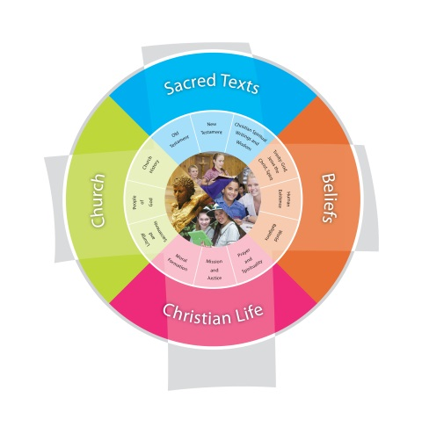
Religion Planning Prep Year “God’s Creation”
Jubilee Primary School Duration: 10 weeks
Fertile Question
What does the goodness of creation look and feel like?
VISION for Religious Education
The Vision for Religious Education gives voice to what each school hopes for their students in terms of their religious literacy and faith formation.
The schools and colleges of the Archdiocese of Brisbane aspire to educate and form students who are challenged to live the gospel of Jesus Christ and who are literate in the Catholic and broader Christian tradition so that they might participate critically and authentically in faith contexts and wider society.

Religious Life of the School | General Capabilities | Cross-Curricular Priorities
Religious Identity and Culture  - Ethos and charism (ICE)  - Authentic Christian community (ICC)  - Sense of the Sacred (ICS)  Social Action and Justice  - Justice in the school community (SJS)  - Action for justice (SJA)  - Reflection on action for Justice (SJR)  Evangelisation and Faith Formation  - Living the Gospel (EFG)  - Spiritual Formation (EFF)  - Witness to the wider community (EFW)  Prayer and Worship  - Christian prayer (PWP)  - Celebration of liturgy and sacraments (PWL)  - Ritualising everyday life (PWR) | - Literacy  - Numeracy  - Information and communication technology (ICT) capability  - Critical and creative thinking  - Personal and social capability  - Ethical understanding  - Intercultural understanding. | - Aboriginal and Torres Strait Islander histories, cultures and spiritualities  - Asia and Australia’s engagement with Asia in a multi-faith context  - Sustainability and ecological stewardship.
Year Level Description
The Religion curriculum involves four strands: Sacred Texts, Beliefs, Church and Christian Life. These strands are interrelated and should be taught in an integrated way; and in ways that are appropriate to specific local contexts.
In Prep, students: learn about some Old Testament and New Testament stories that tell of a God of love, the creator of all. They learn about the goodness of God’s creation, God’s special relationship with all of creation and God’s plan that people help each other to live safely and happily together, for the good of all. They listen to, read and view stories of and about Jesus in the Gospels that tell of Jesus’ life as a Jew, his mother Mary, his friends and family. They learn of Jesus praying and teaching others to pray, of his teachings about love, compassion and forgiveness that challenged people about the way they were living. They learn about his suffering, death and resurrection. They learn that Christians believe God created people with the freedom to choose between good and bad, right and wrong. They explore examples of times when people make these choices, from familiar texts and their personal experience. They understand that prayer helps believers follow the teachings of Jesus; to live according to God’s plan. They learn about ways in which believers pray, either alone or with others, including the Sign of the Cross and Amen. They observe ways in which believers pray together during special celebrations and rituals that mark important times in the life of believers and in the Church year. They learn about the Church building as a sacred place for believers and the Bible as a sacred book for believers.

Achievement Standard
By the end of Prep, students communicate clearly their ideas, feelings and thoughts about God, the goodness of God’s creation and God’s plan that people help each other to live safely and happily together, for the good of all. They identify connections between some Old Testament stories and their personal experience, including experience of the goodness of creation. They listen and respond to stories of and about Jesus in the Gospels that tell of Jesus’ life as a Jew, his mother Mary, his friends and family; of Jesus praying and teaching others to pray; and of his suffering, death and resurrection. They recognise Jesus’ teachings about love, compassion and forgiveness that challenged people about the way they were living. They relate examples of people having the freedom to choose between good and bad, right and wrong. They understand that prayer helps believers to follow the teachings of Jesus; to live according to God’s plan. They recognise ways in which believers pray, either alone or with others, using word, music, action, silence, images, symbols and nature and participate with respect in a variety of these prayer experiences, including meditation, the Sign of the Cross and Amen. They describe ways in which believers pray together during special celebrations and rituals that mark important times in the life of believers and in the Church year.

Class Context for Learning
Multi-faith traditions - Catholic, Anglican, Uniting, Apostolic
Individualised Learning Needs
Practising / Non-Practising members

Learning Intentions
By the end these learning experiences, students will:
- Know and understand that Christians believe that God created the world.
- Identify parts of the world that God created e.g. plants, sun, animals.
- Describe their thoughts and feelings about God’s creation.
- Be able to identify various symbols of prayer.
- Engage in meditative and spoken prayer.

Success Criteria
- Students will make observations and photos of God’s creation through a nature walk. They will be able to clearly communicate ideas and feelings about the Goodness of God’s creation when sharing their photos with their peers.
- Students will be able to participate in meditative and spoken prayer. They will be able to identify and use prayer symbols during their personal prayer experiences.

Assessment
Focus Area 1: Photo-walk of God’s creation. Studentsl choose a part of God’s creation to take a photograph. They will share their photo with the class and communicate their ideas and feelings about the Goodness of God’s Creation.
Focus Area 2: Thankfulness Prayer – students create a prayer of Thankfulness for God’s Creation. They will lead the class in their spoken prayer and begin with the sign of the cross / bowing of their head and complete their prayer with “Amen”.

Content Descriptions
Sacred Texts  Old Testament  New Testament  Christian Spiritual Writings and Wisdom  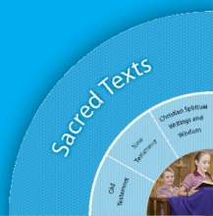 |  | Beliefs  Trinity  Human Existence  World Religions  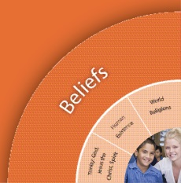
Religious Knowledge and Deep Understanding | Skills | Religious Knowledge and Deep Understanding | Skills
STNT1 - Christians venerate the Bible as a sacred book in many ways, including proclamation in prayer celebrations and meditative reflection in personal prayer. | Use and display the Bible reverently.  Listen with reverence as Scripture is proclaimed in prayerful settings. | BETR1 - There is one God, the source of truth and love, who is creator of all. God’s presence is revealed in the goodness of creation. | Listen and respond to the two creation stories in Genesis  Make links between God and the natural world  Share their ideas about God and creation.
STOT2 - Familiarity with characters, events and messages from some key Old Testament stories (e.g. Creation stories, Noah, Joseph, Moses, Abraham and Sarah) is a means of connecting Scripture and real life. | Listen and respond to Old Testament stories  Share feelings and thoughts about the events, characters and messages in some familiar Old Testament stories.  Make links between some familiar Old Testament stories and their own experiences by sharing characters, events and messages that may be similar or different to their own experiences.
STCW1 - The writer of the first creation story in the Old Testament (Genesis 1:1-31) repeatedly uses the statement “And God saw that it was good” to emphasise God’s special relationship with all of creation.  Jesus’s wisdom challenged people about the way they were living (e.g. The Greatest Commandment: “Love the Lord your God with all your heart, all your soul and all your mind and love your neighbour as yourself.” Matthew 22: 37 – 39). | Share feelings and thoughts about the goodness of God’s creation from their own experience.  Make connections between some of Jesus’ wise statements (e.g. The Greatest Commandment) and how these are expressed in a range of stories (e.g. personal stories, stories of the school’s founders, children’s literature, film, art).
Church  Liturgy and Sacraments  People of God  Church History  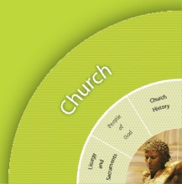 |  | Christian Living  Moral Formation  Mission and Justice  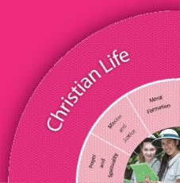  Prayer and Spirituality
Religious Knowledge and Deep Understanding | Skills | Religious Knowledge and Deep Understanding | Skills
 |  | CLPS1 - Jesus prayed regularly and taught others how to pray.  Prayer involves both talking and listening to God, either alone or with others.  Believers pray with the help of word, music, action, silence, images, symbols and nature.  Prayer nurtures the spiritual life of believers. | Identify some occasions when believers pray alone (personal prayer) and pray with others (communal prayer).  Communicate an understanding of the language, gestures, purpose and context of the Sign of the Cross and Amen.  Listen and respond to stories in the Gospels of Jesus praying and teaching others to pray.  Recognise elements that help believers pray (e.g. word, music, action, silence, image, symbol and nature).  Participate with respect in a variety of prayer experiences (e.g. prayer circles, school prayer, thank you prayers) that nurture the spiritual life of believers.
 |  | CLPS2 - Meditative prayer uses silence and stillness to assist believers to listen and talk to God.  There is a range of practices for preparing the body and the mind for meditative prayer (e.g. relaxing the body, centred breathing, attending to posture, being silent and still, recitation of mantras, closing eyes).  A range of spiritual exercises drawn from the Christian tradition helps believers engage in the ‘work of meditation’ (e.g. praying with the help of: beads, labyrinths, images, music, mandalas, mantras, journaling, colour, chimes / bells / rain sticks, candles, symbols, sacred spaces, patterns, rhythms and movement). | Participate respectfully in meditative prayer.  Identify and use practices and spiritual exercises that assist them to prepare for and engage in meditative prayer.

Scriptural Texts
Mandated Scripture  First Creation Story  Genesis 1:1-2: 4a  Creation in Genesis  Genesis 2:4b-9; 15-25  Jesus taught his disciples to pray  Luke 11:1-4 | Supplementary Texts  Noah  Genesis 6:13-9:1  (A re-creation story)

Significant Days and Celebrations

Learning Experiences
Core Content Area One  Focus/Question– THE GOODNESS OF GOD’S CREATION |  | Resources  Teacher Background  Mandated Scriptural Texts
Tuning In | Lesson 1 - Who do you believe created the world? BETR1  - Have students relaxed in preparation for class meditation. Explain to students that for meditation today, we will be viewing a PowerPoint and listening to music (Circle of Life, Lion King Soundtrack).  - Watch the “Who do you believe created the world?” PowerPoint – images of the world, earth, nature, creation. Explain to children that you are going to ask them about what they saw in the presentation.  - PowerPoint reflection (Appendix A. Best if enlarged to A3. Can be used as a part of a class display).  - What did you see in the PowerPoint? Teacher records list of things the children saw.  - What didn’t you see?  - In an effort to gain students’ current understanding of Creation, hold a class brainstorming session around “Who created the world?” Record their ideas on a mind map. Are our ideas the same/different?  - Explain to children that in coming to Jubilee Primary school, they are a part of a special Christian community.  - Once you have collated the children’s ideas, explain to them that ‘As Christians, we believe in one God, a God who created the world and all living things.’ Explain that children and families at Jubilee Primary school, whether Catholic, Anglican, Uniting or Pentecostal, we are all types of Christians.  *The children may not necessarily grasp the abstract concept of these various religions at this age, however introducing this vocabulary and building a common language around Jubilee’s ecumenical community is still an important aspect of early religious education at this school. | PowerPoint presentation – “Who do you believe created the world?”  PowerPoint reflection poster– enlarge to A3 (see Appendix A).  Mind Map (see Appendix B).  Jesus taught his disciples to pray  Luke 11:1-4
Finding Out | Lesson 2 – The Creation Story – STOT2, STCW1  - Sit students down in a circle near your classes’ sacred space. Remind them that when we are in this area, we act calmly and reverently. Ask students to share their ideas about why this is a “Sacred Space”. What is sacred? Refer children to the Bible and remind them that it is a sacred book that holds many stories and messages from, and about God.  - Show children the Golden Box (Godly Play Creation Story). Remind them that the Golden Box holds sacred stories from the Bible as well.  - Explain to children that you are going to share a sacred story from the Golden Box. Refer back to the class mind map about “Who created the world?” Explain to children that ‘As Christians, we believe in one God, a God who created the world and all living things.’  - Open the Golden Box (Godly Play Creation Story) and follow the script and prompts inside as you share “The Creation Story” with them for the first time.  Lesson 3 – God created the world: Reviewing the Creation Story  - As a whole class view the beautiful video adaptation of the Creation Story (link below). Prepare students by informing them that you are going to ask them the following questions after viewing the video.  - Who created the world?  - How long did it take God to create the world?  - What did he create first, second, third…etc?  - http://www.youtube.com/watch?v=bLHB_hNk42g – The Creation Story.  - Reflect on the video and ask the children to share their answers to the questions above.  - Creation story craft – split children up into 6 groups. Each group will decorate the number poster representing what God created on that day. See Appendix C for example.  - Learn the Creation Song – choose from the options most suitable below.  - http://www.youtube.com/watch?v=aoehyq6X650  - http://www.youtube.com/watch?v=SV9ZP8ZTPnM  Lesson 4 – “And God saw that it was Good.” STNT1, STOT2, STCW1  - Sit the class down near your Sacred Space in the classroom. Remind them that when you are in this space, they need to behave calmly and reverently.  - Explain to the children that you are going to read ‘The Creation Story’ from our Sacred book, the Bible. Choose 2 children to reverently collect the Bible and bring it over to you.  - Teach the class that the Creation Story is the very first story of the Bible, in the book of Genesis. It is actually called “The Beginning” rather than the Creation Story.  - Read the story to the class. As you read, emphasis the phrase “…and God saw that it was good,” each time that it is mentioned.  - After reading, ask the children, why do you think God thought it was good? What do you think was good about God’s creation? | Godly Play – Creation Story  http://www.youtube.com/watch?v=bLHB_hNk42g - The Creation Story.  Appendix C – Creation Story Posters.  Copy of large numbers for craft.  The Creation Song links:  http://www.youtube.com/watch?v=aoehyq6X650  http://www.youtube.com/watch?v=SV9ZP8ZTPnM  Bible – Genesis 1: The Beginning
Sorting Out

Communicating | Lesson 5 – Communicating the goodness of God’s Creation BETR1, STCW1  - Revise aspects of God’s creation with the children. Refer to the Creation Story posters on display.  - Show the children a video of our Prep teachers finding and sharing their ideas and feelings about “The Goodness of God’s creation”. Explain that they will be creating their own video as a class after going on a nature walk.  - Prepare the children for a nature walk through the school grounds in search of God’s creation. *Need hats and video recording device e.g. Ipad.  Focused Assessment 1: After walking around for a little, sit students down and explain to them that they are going to choose a part of God’s creation that they believe is ‘good’. Srtudents tell the camera what part of creation they have found and why they think it is good. Questions to prompt them may be:  - What part of God’s creation have you found?  - What is good about it?  - How does it make you feel when you look and touch it?  - Collate the videos and view as a class. What do we like most about God’s creation? How does it make us feel? | Video of Prep Teachers communicating their ideas about the “Goodness of God’s Creation”.
Reflecting and Evaluating | Lesson 6 – reflecting on the Goodness of God’s creation  - Use the following learning object to discuss how to care for God’s creation.  http://www.bne.catholic.edu.au/religious-education-mission/ReligiousEducationCurriculum/Pages/LearningObjects.aspx  - Reflect back on the children’s journey through this unit. View their brainstorming ideas about creation prior to learning about the Creation Story. Read over their Mind Map. Look at the posters they created for each of the 7 days.  - What did I enjoy most about learning about God’s creation?  - Children paint a large painting reflecting what they know about God’s creation. E.g. sky, clouds, sun, moon, animals, people etc.  - Children explain what they like about God’s creation and teacher annotates ideas. | BCE Learning Objects - http://www.bne.catholic.edu.au/religious-education-mission/ReligiousEducationCurriculum/Pages/LearningObjects.aspx

Core Content Area Two  Focus/Question– What is prayer? |  | Resources  Teacher Background
Tuning In | Lesson 1 – What is prayer? CLPS1  - Introduce children to this topic using the “What is Prayer?” PowerPoint presentation.  - Work through each slide on the presentation, pausing for discussion when it arises. There is also a link to a YouTube video included showing Jesus teaching his disciple to pray.  - Focus on the idea that prayer is a way to develop our relationships with God. As we pray we both talk and listen to God.  - Explain to children that at Jubilee "As Christians, we believe in one God". Focus on the idea that not all Christians do the Sign of the Cross and individuals may have different ways to prepare themselves for prayer. Discuss that Catholics make the Sign of the Cross to prepare themselves for prayer. Demonstrate how to make the Sign of the Cross.  - Follow on to explain to students that we all say "Amen" to conclude prayer. Ask students what they believe the meaning of "Amen" is and brainstorm some ideas. Explain that "Amen" means "I agree, I concur, I BELIEVE".  (Continue to refer to the Sign of the Cross and Amen within all class prayer sessions) - PRAYER AND WORSHIP | “What is Prayer?” PowerPoint presentation  Video – Jesus teaching his disciple to pray (included in PowerPoint) - http://www.youtube.com/watch?v=oorNP57iPG4
Finding Out | Lesson 2 – Building a personal symbol of prayer  - Sit children down near the sacred space in your classroom. Revise what ‘prayer’ is with the class. Prior to praying your class prayer, think about what symbols the children could look at in the sacred space that might help centre themselves. Have some children share what they where they are focusing on during prayer e.g. candle, cross, eyes closed.  - After praying together, inform the class that they will be building their own symbol of prayer, a clay cross.  - Clay crosses craft – need clay, baking paper (large piece for each child with name on paper), small bowls, water, aprons, string, rulers and plastic tools to help shape the clay.  - Prepare clay on a large table, with small bowls of water available. Children should also wear aprons. Demonstrate how to make small rectangles using the clay and model to children how to mould 2 rectangles together to build a cross shape.  - Lay clay crosses to dry for1 or 2 days.  - Paint and decorate crosses.  RELIGIOUS IDENTITY AND CULTURE | - Clay  - Baking paper  - Aprons  - Small bowls, water  - Plastic tools, ruler, string  - Paint
Sorting Out | Lesson 3 – Types of Prayer – Meditation  - As children are developing a sense prayer and how it takes place for Christians, remind them that prayer is a way that we can develop our relationship with God. We can both listen and talk to God.  - For a pre-reading into Christian Meditation visit http://www.cominghome.org.au/ for excellent background knowledge.  - Explain to children that meditative prayer is the ‘listening to God’ part of prayer. Meditation is a still, silent and simple form of prayer.  - Have children take part in a meditation prayer. Have them find a quiet space where they can be still and uninterrupted. Explain to them that they are going to begin a guided meditation and that they will need to listen to the instructions given.  - Begin guided meditation – “Safe and Calm for Children, children’s meditation song, The Learning Station” http://www.youtube.com/watch?v=tVM9JKbIIqU  - Once children have completed the meditation, re gather as a whole class. Engage in a class discussion and reflect on how they felt during and after the meditative prayer. | Christian Meditation for Children background knowledge - http://www.cominghome.org.au/  Guided meditation - “Safe and Calm for Children, children’s meditation song, The Learning Station” http://www.youtube.com/watch?v=tVM9JKbIIqU
Communicating | Lesson 4 – Types of Prayer – Spoken  - Have class sit in a circle near sacred space, light a candle and lay the Bible down as well in the centre of the circle.  - Engage in a class discussion about prayer. What do you like to pray about? How do we know what to pray about? Do we always pray about the same thing?  - Inform children that some prayers can be formal and can be found in our sacred text, the Bible. Show them an example of prayer from the Bible e.g. Matthew 6: 7-16 Jesus teaches the disciple the Our Father.  - Explain to the children that there can be prayers for all occasions e.g. Christmas, Easter, sickness, Marriage, celebrations etc.  - Explicitly teach children that when Christians begin prayer they can form the sign of the cross or bow their heads. They also say “Amen” to complete their prayer.  - Continue the discussion with children about their own prayer experiences.  - Inform the class that we will be creating a thankfulness prayer about God’s Creation. Children are to think a part of creation that they would like to thank God for.  - Children write their own “Thank You” prayers during English rotations. See Appendix D for prayer template / or create your own.  Focused Assessment 2: Students take turns to lead the class in a Thankfulness Prayer. They are encouraged to begin and end prayer formally e.g. sign of the cross / bowing of the head, and saying Amen at the end.  *PROJECT – information note for parents, see Appendix E.  - Children take their symbol of prayer, clay cross, home. Children choose a sacred place in their home to place their cross and take a photo of either themselves or a member of their family praying with their cross. Children fill in the Project template and explain where they put their symbol of prayer, what they use it for and when they use it.  - Children’s project template – See Appendix F.  - Children communicate their prayer experiences at home as they present their project. | - Candle, Bible  - “Thank You” prayer template – 1 per child.  - Writing utensils  - Project Sheet – 1 x copy for each child.  - Information note to parents. 1 x copy for each child.
Reflecting and Evaluating | Lesson 5 – What do I enjoy about prayer?  - Sit the class down in a circle in preparation for circle time. Select 2 representatives to select a candle and prayer symbol to place in the middle of the circle.  - Reflect on children’s Prayer Projects and experiences during the unit. What did you enjoy about your project? What is your favourite type of prayer, meditative or spoken? | Class prayer symbols e.g. cross, candle, materials.

Teacher Reflection and Feedback

Religion Unit:
Year Level:
Teachers:

2 STARS
Provide some positive feedback on your Religion Unit below. What activities and lessons were engaging for students? What resources were most useful? Were the lesson plan ideas helpful?
1 WISH
What would you change should you teach this unit again? What resources do you wish you could have used to engage children in this unit more?
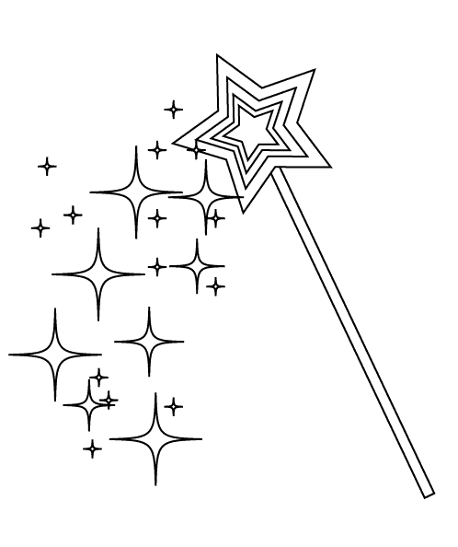

Appendix A.
Who created the world?
PowerPoint Reflection
What did you see?  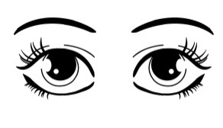 | What didn’t you see?

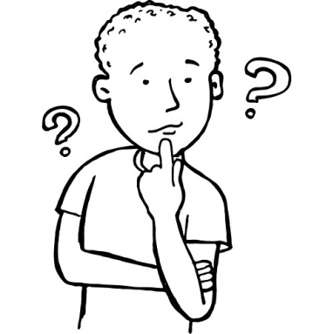
Appendix B
Who do you think created the world?

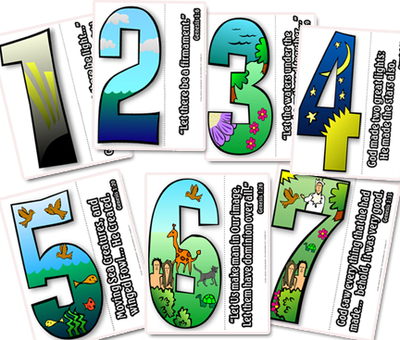
Appendix C.

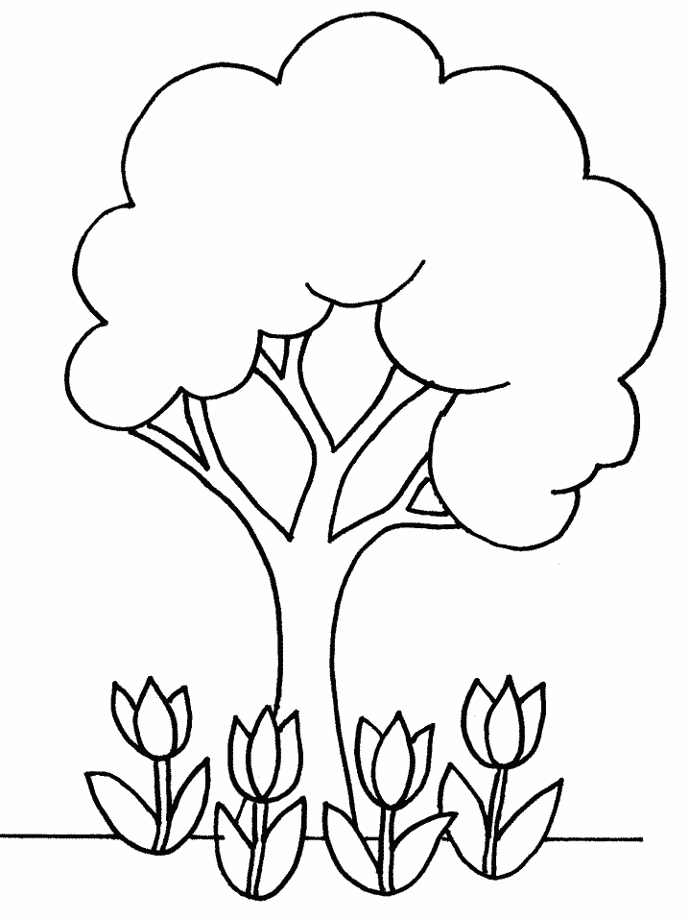
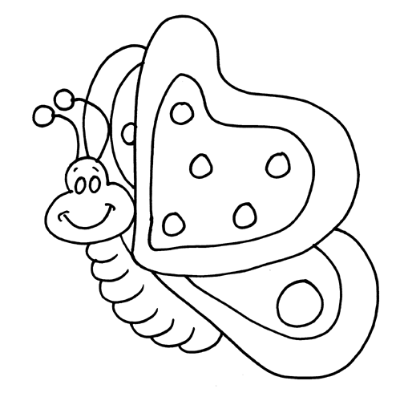
Appendix D.
My Prayer of Thankfulness for God’s Creation

Appendix E.
Dear Prep Parents and Caregivers,

Today your child will be bringing home a prayer symbol. In class this term, the children have learnt about meditative and spoken prayer, and we have viewed various symbols of prayer that people use when developing their relationship with God. Your child has handcrafted and decorated their own cross out of clay.

We have asked your children to find a “special and sacred place” for their clay cross at home. We would also like each child to complete a Prayer Project. Attached you will find their Project template where they will need to answer questions about their prayer symbol and place a photo of their symbol at home. We ask that you please support and assist your child where necessary to complete this project (without completely doing it for them!). Children may decorate their prayer project sheet any way they wish!

All Prayer Projects are due in on ____________________________________________.Please don’t hesitate to ask or email us should you have any questions .

Kind Regards,
Jubilee Prep Teachers
Dear Prep Parents and Caregivers,

Today your child will be bringing home a prayer symbol. In class this term, the children have learnt about meditative and spoken prayer, and we have viewed various symbols of prayer that people use when developing their relationship with God. Your child has handcrafted and decorated their own cross out of clay.

We have asked your children to find a “special and sacred place” for their clay cross at home. We would also like each child to complete a Prayer Project. Attached you will find their Project template where they will need to answer questions about their prayer symbol and place a photo of their symbol at home. We ask that you please support and assist your child where necessary to complete this project (without completely doing it for them!). Children may decorate their prayer project sheet any way they wish!

All Prayer Projects are due in on ____________________________________________.Please don’t hesitate to ask or email us should you have any questions .

Kind Regards,
Jubilee Prep Teachers

MY PRAYER PROJECT
By ______________________
- Where did you place your prayer symbol at home?

_________________________________________________________________________________________________
- When do you pray at home?

_________________________________________________________________________________________________
- Who do you pray with at home?

_________________________________________________________________________________________________

