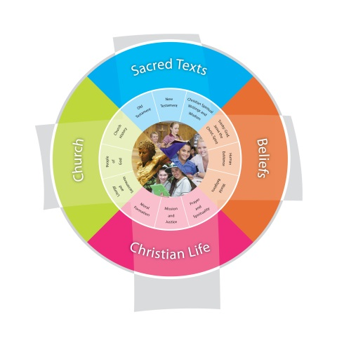
Religion Planning Year 3 “Looking After the World”
Jubilee Primary School Duration: 10 weeks
Fertile Question
How am I created for creation?
VISION for Religious Education
The Vision for Religious Education gives voice to what each school hopes for their students in terms of their religious literacy and faith formation.
The schools and colleges of the Archdiocese of Brisbane aspire to educate and form students who are challenged to live the gospel of Jesus Christ and who are literate in the Catholic and broader Christian tradition so that they might participate critically and authentically in faith contexts and wider society.

Religious Life of the School | General Capabilities | Cross-Curricular Priorities
Religious Identity and Culture  - Ethos and charism (ICE)  - Authentic Christian community (ICC)  - Sense of the Sacred (ICS)  Social Action and Justice  - Justice in the school community (SJS)  - Action for justice (SJA)  - Reflection on action for Justice (SJR)  Evangelisation and Faith Formation  - Living the Gospel (EFG)  - Spiritual Formation (EFF)  - Witness to the wider community (EFW)  Prayer and Worship  - Christian prayer (PWP)  - Celebration of liturgy and sacraments (PWL)  - Ritualising everyday life (PWR) | - Literacy  - Numeracy  - Information and communication technology (ICT) capability  - Critical and creative thinking  - Personal and social capability  - Ethical understanding  - Intercultural understanding. | - Aboriginal and Torres Strait Islander histories, cultures and spiritualities  - Asia and Australia’s engagement with Asia in a multi-faith context  - Sustainability and ecological stewardship.
Year Level Description
The Religion Curriculum involves four strands: Sacred Texts, Beliefs, Church and Christian Life. These strands are interrelated and should be taught in an integrated way; and in ways that are appropriate to specific local contexts. In Year 3, students develop their understanding of God’s relationship with people as individuals and as community, and the presence and action of God in daily life experiences as they engage with a variety of texts (including key stories form the Torah, images of God used in Old Testament texts, and the wisdom of prayers attributed to the saints). They develop an appreciation of the order and harmony of creation. They learn about the cultural contexts in which the Gospels were written and the text types used in the New Testament to develop their understanding of the life and teaching of Jesus and the Christian belief that Jesus is the Messiah. They develop an appreciation of the Scriptures as a basis for Christian moral living, including respect for basic human rights and acknowledgement of responsibilities, in particular to the poor and disadvantaged. They develop an appreciation of the collaboration of clergy, religious and laity as they learn about significant features of a parish and diocese, past and present. They investigate prayers of thanksgiving and prayers of praise, including psalms and doxologies, to facilitate an appreciation of the significance of these forms of prayer for Christians.
Achievement Standard
By the end of Year 3, students select and use information, ideas and events in texts (including key stories from the Torah; images of God used by the human authors of Old Testament scriptures; and prayers attributed to the Saints) to express their ideas about God’s relationship with people as individuals and communities; God’s presence and action in daily life experiences; and the order and harmony in God’s creation. They locate information about the cultural contexts in which the Gospels were written and the text types used by the human authors of New Testament texts. They use this information about the texts to discuss ideas about the life and teaching of Jesus, including the Christian belief that Jesus is the Messiah. They explain how the Scriptures provide a foundation for living a moral life, including respect for basic human rights and acknowledgement of responsibilities, in particular to the poor and disadvantaged. They identify prayers of thanksgiving and prayers of praise, including psalms and doxologies, and demonstrate understanding of the significance of these forms of prayer for Christians. They explain ways in which the Sacraments of Initiation (Baptism, Confirmation and Eucharist) welcome and strengthen members of the Church community. They describe significant people, events and features of a parish and diocese, past and present, including the collaboration of clergy, religious and laity. They participate respectfully in a variety of prayer experiences, including meditative prayer, prayers of thanksgiving and prayers of praise.

Class Context for Learning
Individualised Learning Needs
Multi faith traditions – Catholic, Anglican, Uniting and Apostolic
Practising and Non-practising members.
ASD – ADHD (abstract concepts may need further unpacking – visuals etc…)

Learning Intentions
By the end these learning experiences, students
- Communicate an understanding of order and harmony in God’s creation story.
- Identify meaning and purpose of significant images of God used by Priestly Scholars throughout Hebrew scripture.
- Communicate and demonstrate an understanding of the features of Prayers of Thanksgiving and Praise.

Success Criteria
- Select and use information, ideas and events in texts including key stories from the Torah like Genesis 1-2:4 and images of God used by the Priestly Scholars of Old Testament scriptures.
- Identify Prayers of Thanksgiving and Prayers of Praise, including psalms and doxologies, and demonstrate understanding of the significance of these forms of prayer for Christians
- Participate respectfully in a variety of prayer experiences, including meditative prayer, prayers of thanksgiving and prayers of praise

Assessment
Focus Area 1: Using clay, Students create an image of ‘man’, representing the significance of man in God’s creation plan and that the role of ‘dominion’ means the same as stewardship.
Focus Area 2: Using Hebrew Scripture, students will identify significant images of God and the purpose of these images to create a modern Prayer card, they will also use their Praise and Thanksgiving prayer knowledge to write a Christian message inside their card.
Focus Area 3: Students create their own class ‘Grace’ prayer and Tibetan style Prayer flag (using Praise and Thanksgiving prayer forms), reinforcing the redemptive promise of faith in God.

Content Descriptions
Sacred Texts  Old Testament  New Testament  Christian Spiritual Writings and Wisdom  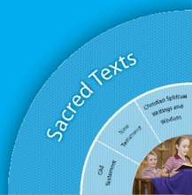 |  | Beliefs  Trinity  Human Existence  World Religions  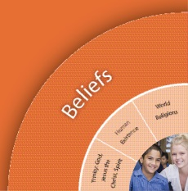
Religious Knowledge and Deep Understanding | Skills | Religious Knowledge and Deep Understanding | Skills
STOT6 - Old Testament scriptures use many different images to portray God (e.g. fire, rain, potter, mother, refuge, sanctuary, lover).  The Psalms are used in prayer, especially in praise of and thanksgiving to God. | Examine the textual features of Old Testament texts (e.g. language, form, use of images, words and phrases in the Psalms).  Speculate on the human author’s reasons for choosing a particular image to portray God.  Communicate personal reactions to various images used to portray God in some Old Testament texts. | BEHE3 - Christians believe that order and harmony arise from the diversity and interdependence of creation. | Identify the diversity of God’s created world.  Explore some of the relationships that exist in the created world (e.g. sun and moon).  Communicate an understanding of order and harmony in God’s creation.
STCW4 - The wisdom of prayers attributed to the saints (e.g. The Deer’s Cry / Breastplate of St Patrick) helps one understand God’s relationship with people as individuals and as community. | Identify the effect on listeners, viewers or readers of the words and images used in some spiritual writings of the saints (e.g. The Deer’s Cry / Breastplate of St Patrick) to express important messages about God’s relationship with people.
Church  Liturgy and Sacraments  People of God  Church History  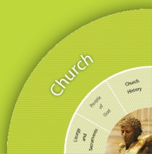 |  | Christian Living  Moral Formation  Mission and Justice  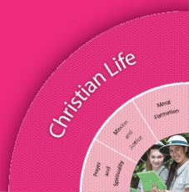  Prayer and Spirituality
Religious Knowledge and Deep Understanding | Skills | Religious Knowledge and Deep Understanding | Skills
 |  | CLPS7 - Prayer involves talking and listening to God, either alone or gathered as community. Believers pray with the help of word, music, action, silence, images, symbols and nature. Prayer in the Christian tradition, including prayers of thanksgiving and prayers of praise, nurtures the spiritual life of believers. Christian spiritual formation calls believers to recognise the presence of God in daily life experiences. | Participate with respect in a variety of personal and communal prayer experiences, including prayers of thanksgiving and prayers of praise, that nurture the spiritual life of believers, calling believers to recognise the presence of God in daily life experiences.
 |  | CLPS8 - In the Christian tradition, essential forms of prayer include prayers of thanksgiving and prayers of praise. For Christians, a primary role of prayer is praise and thanksgiving to a God who knows and cares for each person individually. The Psalms contain many prayers of praise and thanksgiving. Many of Paul’s letters begin or end with prayers of praise and thanksgiving, which have become part of liturgical prayer and hymn collections. Doxologies are hymns or prayers of glory and praise to God (e.g. Gloria, Glory to the Father [Glory Be], and the doxologies of the Eucharistic Prayer and of the Lord’s Prayer). | Communicate an understanding of the features (e.g. language, purpose, structures, gestures, context) of prayers of thanksgiving and prayers of praise (including psalms and doxologies).  Select and use an appropriate prayer structure (e.g. You Who Do Through) to demonstrate an understanding of the role of prayers of praise and prayers of thanksgiving for Christians.
 |  | CLPS9 - Meditative prayer uses silence and stillness to assist believers to listen and talk to God. There is a range of practices for preparing the body and the mind for meditative prayer (e.g. relaxing the body, centred breathing, attending to posture, being silent and still, recitation of mantras, closing eyes). A range of spiritual exercises drawn from the Christian tradition helps believers engage in the ‘work of meditation’ (e.g. guided meditation; praying with the help of: beads, labyrinths, images, music, mandalas, mantras, journaling, colour, chimes / bells / rain sticks, candles, symbols, sacred spaces, patterns, rhythms and movement). | Participate respectfully in meditative prayer.  Identify and use practices and spiritual exercises that assist them to prepare for and engage in meditative prayer.

Scriptural Texts
Mandated Scripture  "I will never forget you"  Isaiah 49:15-16  ThanksGiving and Praise  Psalm 23  Psalm 28;1, 6-9 | Supplementary Texts  God speaks to Elijah  1 Kings 19:11-13a  God as potter  Isaiah 64:8  God as parent  Hosea 11:1-4  God speaks to Moses on the mountain  Exodus 19:16-19  Our Father  Matthew 6:9-15  Luke 11:2-4  Psalms of Praise  Psalms 19, 65, 67, 100, 135, 145, 146, 147, 148, 150  Psalms of Thanksgiving  Psalms 9:1-4, 138  Beginnings from Paul's letters  Ephesians 1:3-5;Ephesians 3:20-21;Philippians 1:3-4;2 Corinthians 1:3-4;Colossians 1:3  Endings from Paul's letters  Romans 16:25-27;Philippians 4:20  Song of the Angels (Gloria)  Luke 2:14

Significant Days and Celebrations

Learning Experiences
Core Content Area One  Focus/Question– What is really created in the Creation story? |  | Resources  Teacher Background  Mandated Scriptural Texts
Tuning In | - Discuss: What is a myth? Myths help explain the unexplainable. A myth is something that cannot be connected to actual people, places or events.  - The Dreaming – parallel of Indigenous Australian myth (stories) used to explain events, rules or the unexplainable.  - Read The Creation Story picture book. (by Norman Messenger). Discuss why this is considered a myth. Make class notes for a wall display  - Discuss: What is the Creation story? What do we know about the Creation myth? | The Rainbow Serpent – traditional version of creation  http://www.youtube.com/watch?v=cLktDAY-bz0  Read: The Creation Story  By Norman Messenger.
Finding Out | - Present the Scripture Box version of the Creation story, using props/figurines. Use discussion notes for reflection.  - Create a Scripture Think Pad - Words, Symbols, Pictures, and Connections to Life.  - Watch the YouTube clip. What does the YouTube imagery show us? Students write down a list of questions to describe who, what, when, how or why.  - Using Bible Gateway attached notes, read parallel Bible versions of the creation story.  - Determine where the creation story is placed in the Bible. What story comes after Creation? Adam and Eve’s – (Fall) story. Why is Genesis 1-2:4 first?  - Complete a Creation story Learning Journal – Note Pinterest page for reference  - Look at the Fertile Crescent on a map and highlight the placement of Jerusalem and the surrounding empires – Babylon. The Creation story was written in exile (Babylonian exile) by at least 2 Priestly Scholars.  - Convergence lesson: Note the proximity of the Babylonian Empire and study the Babylonian creation myth, ‘Enuma Elish for similarities in creation myths.  - Discuss similarities and differences – god like character (Marduk), creator, violent uprising, people created as slaves V’s peaceful daily events, order from chaos, a day to honour the Sabbath, loving and generous God.  - Complete Creation Contrast worksheet (attachments).  - Notes for students books focusing on 7 days (working week and 1 holy day) ethic. Make connections to the balance and harmony in Genesis Creation story.  Creation Story  Function: To unite and orient people in a moral universe.  3 Days of Separation 3 Days of Population  - Light/Darkness - Water/ firmament /water - Water/Dry Land - Sun, Moon, Stars - Birds, Fish - Animals, Human Beings  Story teaches:  - There is one God.  - All creation is good, especially Human Beings.  - Sun and Moon are not gods.  - Human Beings are made in the image of a loving God.  - Keep holy the Sabbath.  Source: And What God said?: An Introduction to Biblical Literacy, Margaret Nutting Ralph  - Harmony - What is it? (Agreement, accord, consistent, orderly)  - Discuss harmony and make a right relationship list of Creation events (day/night, earth/sky, wild and domesticated animals, God’s image/man). What do the 1st Century Israelites learn from the Creation story about God’s harmony? ‘Good’ things happen to His faithful, God is giving and kind, God loves all of his creations as his own children.  - Draw a picture showing harmony in creation – sea / fish, water / dry land, etc. | Natalie Carlson’s Creation - Scripture Box.  Thank you Natalie!  http://kids4truth.com/dyna/creation/english.aspx  Scripture: Genesis 1-2:4  See attached side-by-side versions.  Go to RE, look for A Learning Journal, 7 days of Creation  http://www.pinterest.com/pin/358458451563413359/  Map http://www.usu.edu/markdamen/1320Hist&Civ/slides/11ot/mapfertilecrescent.jpg  Teacher notes: C/: M  The historical context includes the geographic location of Israel, as part of a larger trade route between various empires set on expansion and dominance. ‘Various tribes and ethnic groups’ (Wray pg. 38) resided in close proximity, ‘destruction and occupation were common themes’ (Boadt pg39) throughout the Hebrew Scriptures. Genesis was written in exile, it is possibly this theme of forced slavery that contrasts a Babylonian creation myth known as ‘Enuma Elish’. This contrast effectively demonizes the enemy (at the that time, Babylon was the conquering empire) by offering a preferred peaceful creation myth. The Enuma Elish myth starts with similar origins emphasis ‘when there was neither heavens nor earth…’(Boadt, pg 7). The two creations stories juxtapose, contrasting a peaceful version with violent conflict, gods conquered by a more aggressive god figure, humans created ‘from the dirt and blood of the violently defeated gods’ (Boadt pg 7) and an order imposed through force where humanity serves the god figure (Marduk), as his slaves. Contrasted to the ‘idealistic’ (Baodt pg7) origin legend of Genesis (1:2-4). The Genesis God is the supreme creator who crafts all things “intentionally, peacefully, (in a) perfectly ordered” world made in the ‘right’ relationship to its creator God (Baodt pg7).
Sorting Out

Communicating | Focus Assessment 1: Using clay, students create an image of ‘man’, representing the significance of man in God’s creation plan and that the role of ‘dominion’ means the same as stewardship. Verbally explain how the clay creation demonstrates ‘harmony’ with God.
Reflecting and Evaluating | - Hot seat interview: Students explain their Creation representation and their understanding of God’s relationship with creation.

Core Content Area Two  Focus/Question – Why use that image of God? |  | Resources  Teacher Background
Tuning In | - What is an image? What is a symbol?  - Watch YouTube clip - Describe the attributes of the image (strength, power, creator, caring love, refuge)  - Make keynotes listing images using Deer’s Cry imagery. | Deer’s Cry – Prayer of Saint Patrick, rich in imagery.  http://www.youtube.com/watch?v=GGHWiAGpIP0
Finding Out | - Display picture images for discussion. Students look at Hebrew Scripture images (e.g. fire, rain, potter, mother, refuge, sanctuary, lover).  - See attached images – clay, wind, burning bush, photo of students, etc.  - Use Bible skills to locate relevant Psalms. – Type of poetry, spanning centuries in existence from Babylonian Exile period, has metaphorical and symbolic meaning. See attached parallel verses.  - Review Parallel verses Psalm 29 (attachments).  - Highlight images  - Use: The Book of Psalms  - Highlight praise and thanksgiving words  - Highlight the titles, beginnings and endings, note the emotive and descriptive words.  - Song 1 (Andrew Chin) about images and their connection to God and His creation – I am the River.  http://www.youtube.com/watch?v=XhWZPggdG7g  - Song 2: Play Andrew Chin – Rainbow song  - Draw a scene using these images. Annotate the attributes of these images. (Water – cleansing, renewal; Rainbow – reborn, fresh start) | Images attachment.  The Book of Psalms. (attachment).  Copies of parallel Psalm 29 Youtube prayer format + parallel verse.  http://www.beliefnet.com/Faiths/Christianity/Bible/Thanksgiving-Bible-Verses.aspx  Year Level scripture selection:  Psalms of Praise: Psalms 19,65,67, 100, 135, 145, 146, 147, 148 149, 150;  Psalms of Thanksgiving: Psalms 9, 30, 75,107,138  Song 1 about images and their connection to God and His creation – I am the River (Andrew Chin). YouTube.  Song 2. Andrew Chin – Rainbow Song C/- School Music Library.
Sorting Out
Communicating | - Design a draft prayer card (Card intended for their family). Select an image to represent God on the cover. Annotate reasons why this image was chosen, use topic related words to explain images.  Focus Assessment 2: Using Hebrew Scripture, students will identify significant images of God and the purpose of these images to create a modern Prayer card, they will also use their Praise and Thanksgiving prayer knowledge to write a Christian message inside their card.
Reflecting and Evaluating | - Swap card drafts, students reflect and discuss on images. Discuss general suggestions for improvement.

Core Content Area Three  Focus/Question– Prayer Appreciation |  | Resources  Teacher Background
Tuning In | - Discuss: What is Prayer? = Worship the Divine. The way in which humans communicate with their God. Every religion has their own set of prayers, rituals and modes of worship. 125 000 – 30 000 BCE – Neanderthals ritually buried their dead (the action of prayer is very, very old).  - Watch the YouTube clip – Images: worship the Divine (links to Creation & Images of God unit). List images, discuss language and topic related words. | http://www.deeper-devotion.net/breastplate-prayer.html
Finding Out | - Explore basic Types of Prayer – Notes in book.  - Praise – glorifying God  - Thanksgiving – gratitude  - Penitential – God’s forgiveness  - Petition – asking for something  In Kid’s Language.  - Happy moments, praise God.  - Difficult moments, seek God.  - Quiet moments, worship God.  - Painful moments, trust God.  - Every moment, thank God.  - Represent ‘The Lord’s Prayer’ in images.  - Create a prayer ‘Blessings’ jar. Students write someone’s name on a small card and place in the Prayer jar  - Explore Types of Prayer (Review Deer’s Cry as a prayer type). Read the Bible verses. Discuss language, modality, emotive words, in relation to God’s harmonious relationship with man, etc. Highlight and list praise words. Highlight and list thanksgiving words. | The Lord’s Prayer in Images  http://www.pinterest.com/pin/179792210098206288/  http://www.pinterest.com/pin/232146555762175177/
Sorting Out

Communicating | - Write a draft prayer, intended for the inside of their prayer card. Discuss language and card’s purpose. Complete the Prayer card.  - Tibetan Prayer Flags - Watch the PowerPoint and discuss different types of prayer. Note-take for reference.  Focused Assessment 3: Students create their own class ‘Grace’ prayer and Tibetan style Prayer flag (using Praise and Thanksgiving prayer forms), reinforcing the redemptive promise of faith in God. Incorporate the Tibetan colour scheme. Prayer format example:  Purpose of Prayer- (Thanking) We give thanks to You, Creator God).  Reasons for thanks – Thank you for the rain, my family’s love, etc.  Reaffirm Purpose – You are our God; we give you thanks, etc.  Artistically draw an image representing God on the other side of Prayer Flag.  - Students take turns to lead the class Morning Prayer using their prayer flag. | Tibetan Prayer Flag Powerpoint  http://www.tesaustralia.com/teaching-resource/Tibetan-Prayer-Flags-6333171/
Reflecting and Evaluating | - Hang Flags in order of colour. Students reflect on types of prayer, the language and images used.  - Use ‘Todays Meet’ - interactive tool to discuss card images and reasoning. Sentence starters for Todays Meet could focus on  Your chosen image reminds me of…….  I like how you….

Teacher Reflection and Feedback

Religion Unit: | Looking after Gods World
Year Level: | 3
Teachers: | Zoe Parry, Merridee Lynes

2 STARS
Provide some positive feedback on your Religion Unit below. What activities and lessons were engaging for students? What resources were most useful? Were the lesson plan ideas helpful?
 | The students looked at the local origin story of the Yugumbeh people. We created totems that are displayed in the garden outside the year 3 classrooms in the Hub that tell Gods creation story in images, Yugumbeh Origin story in symbols and images.
 | Online resources linked in unit helpful.
1 WISH
What would you change should you teach this unit again? What resources do you wish you could have used to engage children in this unit more?
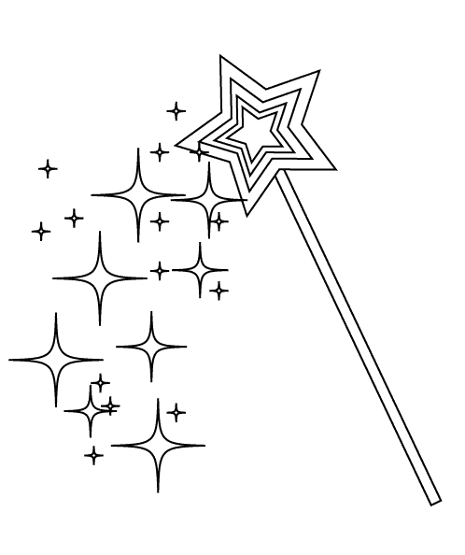 | It would be great to have visual images /resources laminated for Teaching Psalms and Images of God that we could use where children can label, match psalms to the image using specific scriptural reference.

